**CYBER SECURITY WEEK 5 ASSIGNMENT(MANAGE AUTHORIZATION)**

**OLANREWAJU ADESINA FE/23/10260344**

**Assignment**: Using numerical representation and the two files file1 and file2 created in week 4, create user1 group and then grant user1 read-only access to file1 and all access to file2, also grant group1 read-only access to file2 and all access to file1.

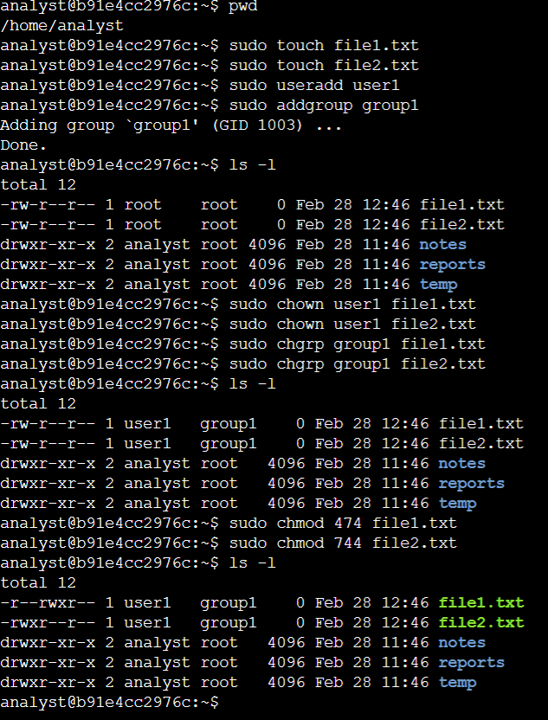

First, I checked my present working directory(pwd), then I created file1.txt and file2.txt using sudo touch file1.txt and sudo touch file2.txt command

I also added a new user ‘user1’ and a new group ‘group1’ using sudo useradd user1 and sudo addgroup group1 command respectively. Then I checked for the list of permissions using ls –l command.

Both file1.txt and file2.txt have read and write permissions for the user(root) and only read permission for the ‘group’ and ‘others’. I changed the ownership of both file1.txt and file2.txt to the newly created user(user1) using chown command. I also changed the primary group of file1.txt and file2.txt to the newly created group(group1) using chgrp command then I used the ls –l command to verify the changes.

To grant user1 read-only access to file1 and all access to file2 while maintain the read-only access for ‘others’ in both file1.txt and file2.txt, I used the command sudo chmod 474 file1.txt and sudo chmod 744 file1.txt respectively. Finally, I used the ls –l command to verify the changes to the permissions.